# MOTOR CALCULATION

In this project, the parameters are given in the nameplate of the DC motor. Nameplate can be found in Figure 1. Also, specifications of the motor windings can be found in Figure 2.

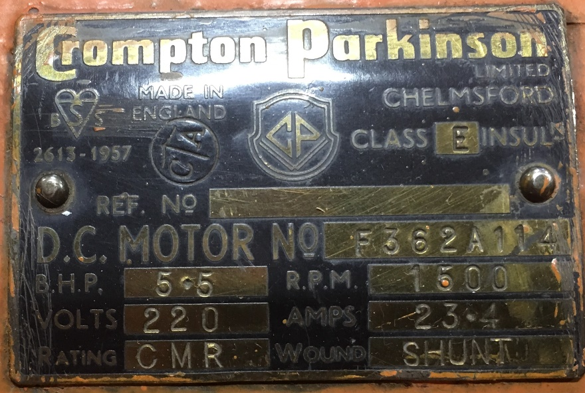

Figure 1. Nameplate of the DC motor

metin içeren bir resim

Açıklama otomatik olarak oluşturuldu

Figure 2. Specifications of the motor windings

It is stated in the project definition that any type of connection can be done. We have chosen to connect motor with shunt connection. A model of this representation can be found in Figure 3.

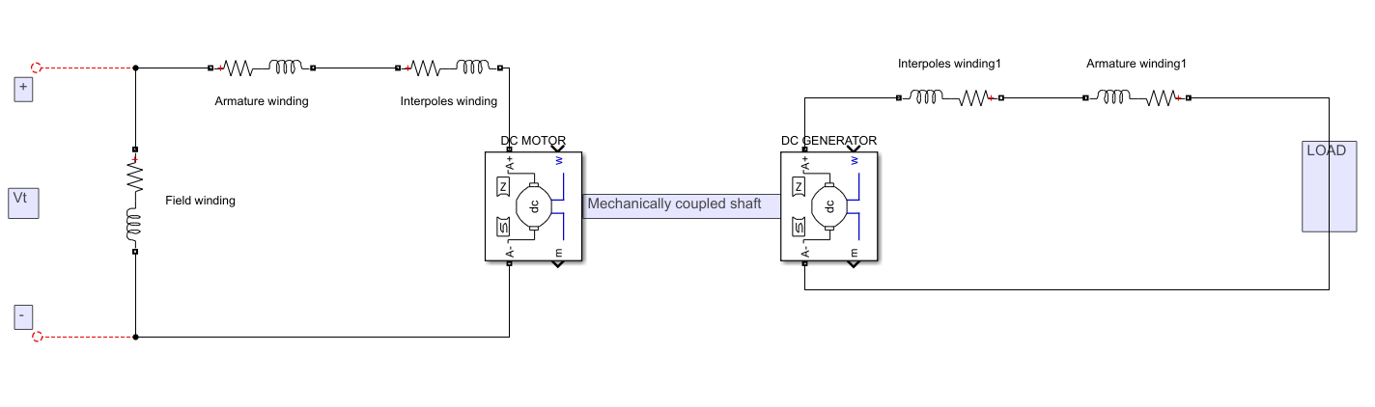

Figure 3. Shunt connection of DC motor mechanically coupled to DC generator

Required values to calculate motor parameters at full load can be found using the nameplate in figure 1.

The rated electrical input to the system is . So, total loss of the system can be calculated as . There are losses in the system introduced by the armature resistance, field resistance and interpole resistance.

So, after subtracting these losses from the total loss, we can obtain resistance losses in the motor.

Now, Coulomb friction loss (must be found to obtain the friction losses at different speed. To obtain that value formulization will be used.

It is stated in the project that output voltage of the DC motor drive () should be less than 180 V. After analytical calculations, we have decided to have 170 V at the output voltage. Beyond that point, will be used in the calculations.

* Assuming motor at start-up,

(Since motor is shunt connected)

As it can be seen from above calculations, start-up current is high, and this start-up current can damage the motor since full load current of the DC motor is 23.4 A. To decrease the start-up current low should be applied by changing the duty cycle of the operation. By doing so, we have managed soft start operation.

* Assuming motor is working at no load condition,

At no load, mechanical power comes from the friction losses ( = ). So, by using the obtained Coulomb friction loss total mechanical power required for no load operation can be found. By using equation, speed of the no load condition can be calculated. After that, by multiplying with speed will result in total friction loss. In our calculations we have assumed also we have neglected the losses in armature and interpole windings (.

So, friction losses can be calculated as,

Since the motor and generator are same and coupled, we can conclude that total friction losses in no load case is approximately 280 (W).

* Assuming motor is working at kettle load,

To obtain the Tea Bonus, our driver should be able to supply minimum 2kW for at least 5 minutes. We are required to find the power that is transmitted to the motor. Motor will be working at 2000 (W) also there are additional friction losses calculated for no-load condition which is 280 (W). So, without armature, field and interpole losses, 2280 (W) power is required. To find exact value, armature current must be found.

,

By equating these two equations, armature current can be found.

So, total power required can be calculated as follows.

Based on our simulation results where all components are ideal, we can generate almost 3.5 (kW) power at the input side of the motor.

# COMPONENT SELECTION

Based on our investigations on our model, we have selected the following components.

* GUO40-12NO1 Bridge Diode
* IXGH24N60C4D1 N IGBT
* 100 µF 400 V Electrolytic Capacitor
* **DSEP30-06B (HiperFRED 30A 600V 30ns) diode**

## GUO40-12NO1 Bridge Diode

For rectifying diodes in the input side, we have decided to use 1 bridge diode rather than six different normal diodes to increase compactness after our discussions. Based on our simulations, rectifier diodes must be capable of working at least 220 V reverse blocking voltage and 23.4 A forward current. The chosen bridge diode has 40 A, 1200 V specifications which enables us to operate safely.

tablo içeren bir resim

Açıklama otomatik olarak oluşturuldu

Figure 4. Datasheet of GUO40-12NO1

## IXGH24N60C4D1 N IGBT

After observing the simulation, it was concluded that MOSFET/IGBT must work at least 220 V and 18 A. The chosen IGBT can operate properly until 600V, 30 A.

tablo içeren bir resim

Açıklama otomatik olarak oluşturuldu

Figure 5. Datasheet of IXGH24N60C4D1 N IGBT

## 100 µF 400 V Electrolytic Capacitor

We have added a capacitor after the rectifier part to decrease the voltage ripple. This capacitor should work properly at almost 250 V so after adding a safety margin, we have concluded to use 100µF 400 V capacitor.

## DSEP30-06B (HiperFRED 30A 600V 20ns) diode

Reverse blocking voltage of freewheeling diode is observed as 220 V and forward current observed as 20 A. Also, freewheeling diode should be fast, so we have chosen to work with this diode. This diode can work until 600 V, 30 A.